**ANTHONY SEADLER**

Full Stack Software Developer

(502)-777-7878 | aj6287@gmail.coml | Oklahoma City, OK | [linkedin.com/in/anthony-seadler](https://www.linkedin.com/in/anthony-seadler) | [github.com/ajSeadler](http://github.com/ajSeadler) | [anthonyseadler.com](http://anthonyseadler.com) | **Certificate of Web Development - Oklahoma University / Fullstack Academy**

**TECHNICAL SKILLS**

**Proficient:** *Node.js, JavaScript, React.js, Postgres, SQL, Python, Flask, Git, Github, Express, HTML5, CSS, Bootstrap 5, Material UI*

**Knowledgeable:**  *Vue, Angular, Ruby*

**TECHNICAL PROJECTS**

**Fork-It (Reviews website)** | **Front and Back-End** | Oct.-Nov.2023 |<https://github.com/ajSeadler/Fork-it>

* Designed and developed a review website for local restaurants, enabling user sign-up and login to leave reviews.
* Developed with the PERN stack.
* Utilized Postgres and Express.js to complete the back-end.
* Built via React.js and Node.js - styled with MUI and Bootstrap 5
* Utilizes JWT and bcrypt, ensuring passwords are efficiently hashed and secure, letting users have a comfortable experience with the site.
* Strict user permissions.
* Web-site also features an admin page where an administrator can create, remove, or edit reviews/restaurants.

**Band Website** | **Full Stack** **Developer** | Sep. 2023 | <https://github.com/ajSeadler/Disco-Stranger-Site>| [discostrangermusic.com](https://discostrangermusic.com/)

* Created a professional website for the rock band "Disco Stranger," to enhance their online presence and engage with their audience effectively.
* Designed and developed a visually appealing and responsive website that showcases the band's music, videos, and upcoming events.
* Implemented a countdown timer to build excitement for the band's upcoming shows.
* Utilized React.js and Node.js to create an engaging user experience.
* Incorporated social media integration to increase the band's online visibility.
* Ensured mobile responsiveness for a seamless user experience on all devices.

**The Legend of Zelda Compendium** | **Full Stack Developer** | Sep. 2023 | <https://github.com/ajSeadler/Zelda-Encyc.>

[https://zeldainfo.netlify.app](http://zeldainfo.netlify.app)

*The Legend of Zelda Compendium is a fan made (by myself) website where users can look up various types of information from the video game series The Legend of Zelda.*

* Developed a mobile-responsive web app for Zelda fans, offering quick access to in-depth information on games, dungeons, monsters, and equipment.
* Leveraged React and a REST API for a seamless user experience, focusing on responsive design and efficient data display.

**EcoSync (Fake product site)** | **Full Stack Developer** | Oct. 2023 |<https://github.com/ajSeadler/ecosync> | <https://fakeproduct1.netlify.app/>

*The EcoSync Smart Garden website is a visually appealing and user-friendly online platform that showcases expertise in web design and development. Key highlights of the website include:*

* ***Responsive Web Design***: Designed a fully responsive website that adapts to various screen sizes and devices, ensuring an optimal user experience on both desktop and mobile.
* ***Mobile-Friendly Navigation***: Implemented a mobile-friendly navigation menu with a toggle button for seamless navigation on small screens, enhancing accessibility for mobile users.
* ***Interactive Features***: Enhanced user engagement with interactive elements, such as smooth scrolling, hover effects, and a dynamic mobile navigation menu that opens and closes when needed.
* ***Hero Section Optimization***: Improved the hero section with an eye-catching image, overlaid text, and call-to-action buttons, creating a visually appealing and professional introduction to the website.

**EDUCATION**

**Fullstack Academy Web Development Bootcamp** June 2023 - Dec. 2023

Software Engineering Certificate

Full-time, Full Stack Javascript Web Development Immersive

**University of Louisville** *December* 2023

Bachelor of Science in Communications

GPA: 3.0

**South Oldham High School** August 2011 - June 2015

Class of 2015

GPA: 3.5

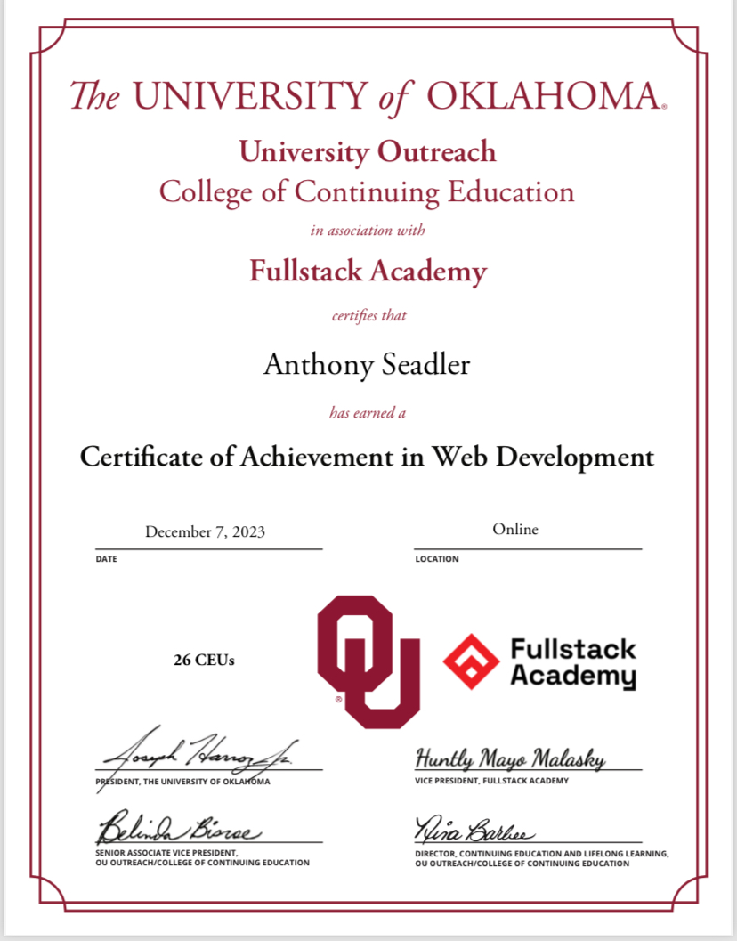

**WORK EXPERIENCE**

**Treatment Team Manager** | **Community Pathways Unlimited**| Oklahoma City, OK09/2021 - currently employed

**Basic Functions** - *To oversee and manage the prior authorization process as determined by The Department of Mental Health*

* Coordinate with clinicians to ensure all information to complete extensions is turned in.
* Maintain positive communication with The Department of Mental Health
* Update service units approved by The Department of Mental Health and inform the appropriate persons.
* Track extension renewal dates and assign staff to complete
* Supervise work of prior authorization specialist

**Bookseller** | **Half Price Books** | Louisville, KY - Oklahoma City, OK | 08/2017 - 09/2021

**Basic Functions** - *As a Bookseller at Half Price Books, I specialized in buying books from the public, meticulously valuing them using our software, skillfully managing point-of-sale operations, and diligently maintaining the organization of store book sections.*

* Book Appraisal: Proficient in assessing book value through thorough research and market analysis.
* Customer Service: Exceptional ability to assist and engage with customers, offering recommendations and addressing inquiries.
* POS Operations: Adept in efficiently handling cash, credit/debit transactions, and maintaining accurate transaction records.
* Inventory Management: Expertise in organizing, displaying, and tracking book inventory to ensure a well-stocked and updated store.
* Book Knowledge: Comprehensive understanding of diverse book genres, authors, and industry trends.
* Attention to Detail: Keen eye for book condition and inventory accuracy, ensuring a high-quality nd accurate offer on customer items being sold..
* Teamwork: Collaborative spirit, contributing to a harmonious team and store operation.
* Communication: Effective communication skills for customer interactions and team collaboration.
* Problem-Solving: Proven ability to address customer queries and resolve issues efficiently.
* Time Management: Proficient at task prioritization, deadline management, and maintaining store efficiency.